RESIDENTS / INPATIENT ROTATION
MSH and MSW EMU Rotation:
AM workflow (~7am-12pm):
7-8AM: Arrive and preround on patients (EMU and epilepsy consults)
8-9AM: Attend morning report
9-10AM: Read at least one LTM EEG (first week: EMU study, second week: one EMU and one ICU study) and draft EEG reports. The residents on the epilepsy rotation should be assigned to read at least 1 long term EEG in the morning and continue writing EEG reports on these patients until the end of monitoring. When EEG monitoring is finished for the patient, pick up another patient.
Between 10 AM till 12 PM: Round with epilepsy fellow/attending
PM workflow (12-5PM):
12-1 PM : Attend neurology noon conference 12-1 PM (MSH)
1-5 PM: Elective admission H&Ps, epilepsy consults, follow-up on LTM EEG that you read, read new inpatient routine EEGs (at least 1-2) and a new LTM EEGs (if the EEG you were following was discontinued)
Neurology residents’ ACGME milestone
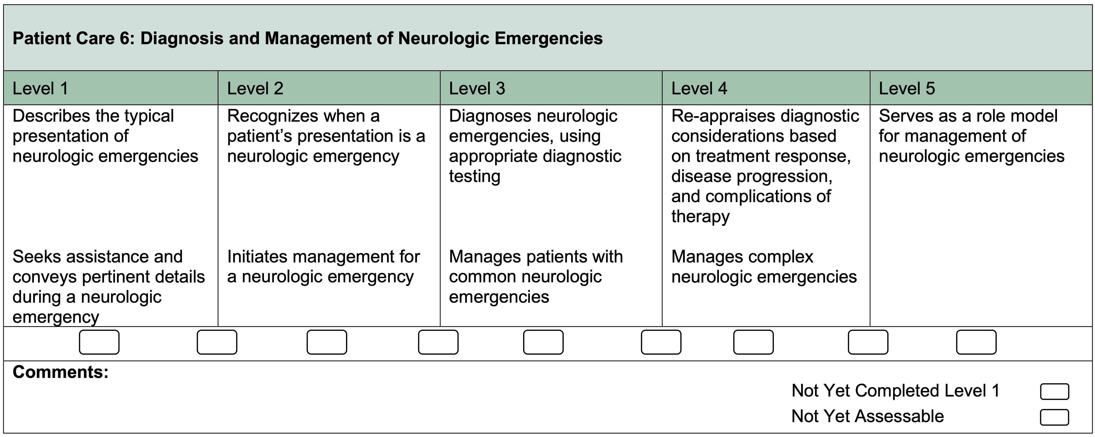

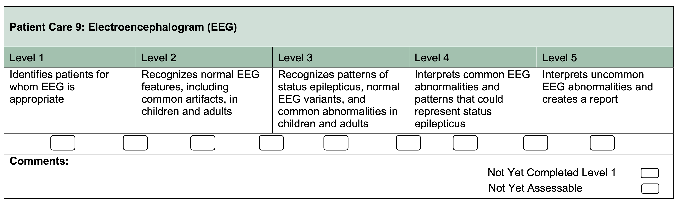

RESIDENTS / OUTPATIENT ROTATION
MSH Amb EEG/Outpatient Rotation (MSH PGY-2)
8-9AM: Attend morning report
AM: Epilepsy Clinic or EEG reading- if no clinic, self-study and outpatient EEG reading
PM: Residents’ continuity clinic or faculty clinic, Ambulatory EEG readings with the ambulatory block attending (Discuss time of rounding with ambulatory block attending)
 | Monday | Tuesday | Wednesday | Thursday | Friday
AM (9-1) | Self-directed EEG Learning | Blank  (MSH) | Outpatient EEG reading | Outpatient EEG reading | Yoo  (MSH)
PM (1-5) | Resident clinic | Outpatinet EEG reading  & round with AEEG block attending | 1-2 PM: fellow conference  2-4 PM: Outpatient EEG rounding  4-5:30 PM:  MDC conference | Outpatient EEG reading  & round with AEEG block attending | Resident clinic
** Note: Faculty clinic schedule will vary depending on their inpatient rotation schedule. If the clinic attending does not have AM clinic, self-read routine EEGs and go over them with the ambulatory EEG attending in the afternoon.

MSW Outpatient rotating Residents: (MSW PGY-2s)
AM: Epilepsy Clinic (if no clinic, self EEG reading)
PM: Ambulatory EEG readings with the ambulatory block attending
 | Monday | Tuesday | Wednesday | Thursday | Friday
AM | Fields  (MSW) | Blank  (MSH) | Singh  (MSH) | Marcuse (MSW) | Yoo  (MSH)
PM | EEG reading | EEG reading | EEG reading | EEG reading | Didactics
** One afternoon will be spent in their continuity clinic (Tue/Wed/Thu)
**First &Third Thu AM – continuity clinic
** Post-calls (q6-7) for PGY-2s
** Drs. Fields and Marcuse’ clinics are at MSH on the 4th week.
** Note: Faculty clinic schedule varies depending on their inpatient rotation schedule. If the clinic attending does not have AM clinic, self-read routine EEGs and go over them with the ambulatory EEG attending the day or the next day.
TEACHING ROUNDS
(All epilepsy conferences are held via zoom currently)
Name of Seminar | Day of Week | Time | Location | Description | Participants
Epilepsy surgery conference  (mandatory) | Wed | 4-5:30 pm | Levy Library (MSH) / Zoom | Epilepsy Surgery Cases | Comprehensive Epilepsy Team
Teaching Rounds /  Interesting EEG cases  (mandatory) | Wed | 1-2 pm | Zoom | 1st : ICU EEGs (fellows present – joint conf with NSICU)  2nd and 4th: Faculty lecture series  (see below schedule)  3rd week:  Interesting EEGs (fellows and attendings present)  5th week:  Other | Epilepsy attendings on service, fellows, residents, students, EEG technicians
Grand Rounds | Fri | 8-9am | Hess Center  (remote access available) | Neurology Grand Rounds | Neurology faculty, fellows, residents, students
EEG conference with residents | Fri  (Biweekly- 2nd Fri of the block) | 12-1 pm | Anbg 14th floor conf room | Attending/Fellow on service go over interesting EEG cases for the block | Residents, fellows,  Students,  attending on service

